**Fixed Effects vs. Random Effects**

I first performed a Hausman test, which tests for correlations between the regressors and the error terms, to determine whether to use a fixed effects or random effects model. The regressors indeed appear correlated (p < 0.01), which suggests a fixed effects model is more appropriate. In fact, plotting residuals over time illustrates the moderate negative correlation between error terms.



**Instrumental and Dummy Variables**

The countries in the dataset represented two regions: Western Europe and Latin America. Consequently, I ran separate regressions for each region. I also created a dummy variable for the Great Recession that included all years between 2008 and 2012. However, I removed this variable from the final model because it was not significant (p > 0.5).

**Best-Fit Model**

As with previous models using this dataset, I divided the data into two regions: Europe and Latin America. The model that best fit the data from Latin American countries was:

*log_annual_gdp_growth* = *β0 + βijlog_gross_fixed_capital + βijlog_pop_growth_annual + βijlog_trade_pct_gdp + εit*

where:

* *log_annual_gdp_growth* is the log of the per-capita GDP annual growth,
* *log_gross_fixed_capital* represents the log of gross fixed capital formation as a percentage of GDP,
* *log_pop_growth_annual* is the log of annual percent change in population, and
* *log_trade_pct_gdp* represents the log of trade flows as a percentage of GDP.

The table below lists the coefficients, significance levels, R2, and sigma and rho values for the regression using only countries in Latin America.

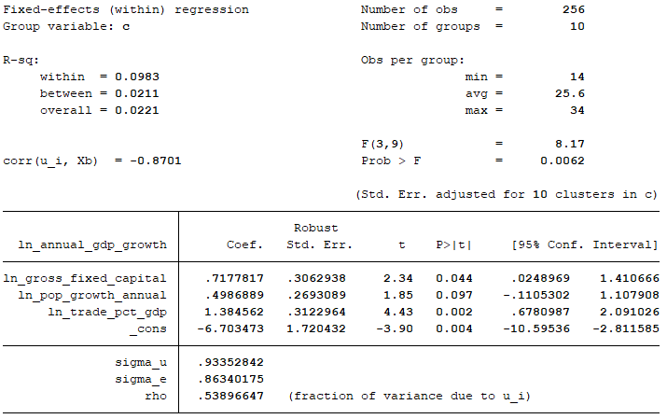

As you can see from the table, all coefficients are significant at p < 0.1 or less, and the rho statistic indicates that this model explains nearly 54 percent of the variation across panels.

The model that best fit the data from European countries was:

*log_annual_gdp_growth* = *β0 + βijlog_gross_fixed_capital + βijlog_pop_growth_annual + βijlog_gov_exp_edu + εit*

where:

* *log_annual_gdp_growth* is the log of the per-capita GDP annual growth,
* *log_gross_fixed_capital* represents the log of gross fixed capital formation as a percentage of GDP,
* *log_pop_growth_annual* is the log of annual percent change in population, and
* *log_gov_exp_edu* represents the log of total government expenditures on education.

The table on the following page lists the coefficients, significance level, and R2 for the regression using only countries in Europe. All predictor variables are significant at p < 0.03 or less, and the rho statistic indicates that this model explains more than 21 percent of the variation across panels.

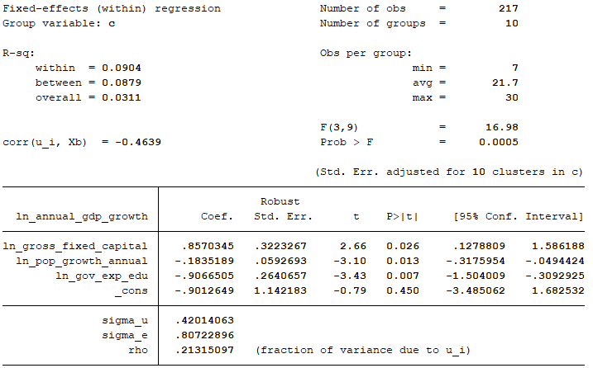

**Robust Standard Errors**

I applied robust standard errors to account for the heteroscedasticity I had observed in the data through other analyses.

**Discussion**

It is worth noting that government expenditures on education were significant for countries in Europe but not for countries in Latin America, and the opposite was true with regards to trade as a percentage of GDP. The latter makes intuitive sense. The European Union was officially established in 1993, though the decade leading up to that year, which represents the first years represented in the dataset, was characterized by greater European cooperation. As such, large trade volumes became less indicative of a country’s overall economic health, as measured by its change in per capita GDP. Conversely, Latin America is relatively isolated from the rest of the world and has relatively low intra-regional trade. Consequently, trading relationships with wealthy countries in other regions stood to improve the economic conditions of those countries.

The differential impact of education spending proves harder to explain. Part of the reason this predictor is significant for Europe but not for Latin America could be that spending on education showed considerable variation through the mid-1990s but significantly stabilized across Latin America in later years (see graph on following page). This consequently could have reduced the impact of education expenditures on per capita GDP growth.

